

Austin Health Animal Ethics Committee

**STANDARD OPERATING PROCEDURE**

|  |  |
| --- | --- |
| **Author:** |  |
| **Version:** |  |
| **Date:** |  |

|  |
| --- |
| **Office Use Only** |

|  |  |
| --- | --- |
| **Standard Operating Procedure Number:** |  |
| **Date Approved by AEC:** |  |
| **Review by AEC Due:** |  |

**1. TITLE**

**2. PURPOSE / AIMS OF PROCEDURE**

**3. IMPACT TO ANIMALS**

**4. MATERIALS AND PERSONAL PROTECTIVE EQUIPMENT REQUIRED**

**5. PROCEDURE**

(Include relevant information such as location, pre/post-surgery procedures and monitoring. Describe in steps the procedure, numbering each step and using lay terms).

**6. WASTE DISPOSAL CONSIDERATIONS**

**7. SAFETY / RISK ASSESSMENT (Personnel and Animal Care Staff)**

|  |  |  |  |  |  |  |
| --- | --- | --- | --- | --- | --- | --- |
| **1. ISSUE** | **2. RISK** | **3. CURRENT CONTROLS** | **4. RISK RATING** | | | **5. Strategies / Actions / Escalation** |
| *What is the issue?* | *Briefly outline the risk:*  *E.g. The risk of (what/where/when) caused by (how) resulting in (impact consequences)*  ***Please see the Risk Matrix on the Austin Health website for reference.*** | *What devices, systems or processes are in place to reduce the likelihood or consequences of harm occurring?*  *E.g. safety mechanisms, checking procedures, policies and procedures.*  *How effective are the ‘controls’?* | *Taking into account the effectiveness of the ‘controls’ currently in place, use the criteria in the Risk Matrix Procedure (below) for calculating ‘likelihood’, ‘consequences’ and overall ‘risk rating’.* | | | *What actions are needed to reduce the risk to an acceptable level?* |
| **Likelihood**  *E.g. possible* | **Consequence**  *E.g. medium* | **Risk Rating**  *E.g. high* |
|  |  |  |  |  |  |  |
|  |  |  |  |  |  |  |
|  |  |  |  |  |  |  |
|  |  |  |  |  |  |  |



***Appendix 2 Hierarchy of Controls***

Controlling health and safety risks in the workplace is necessary to prevent injury and illness.

Consideration of the possible control measures should continue down the hierarchy until a control measure or a combination of measures can achieve the reduction in exposure.

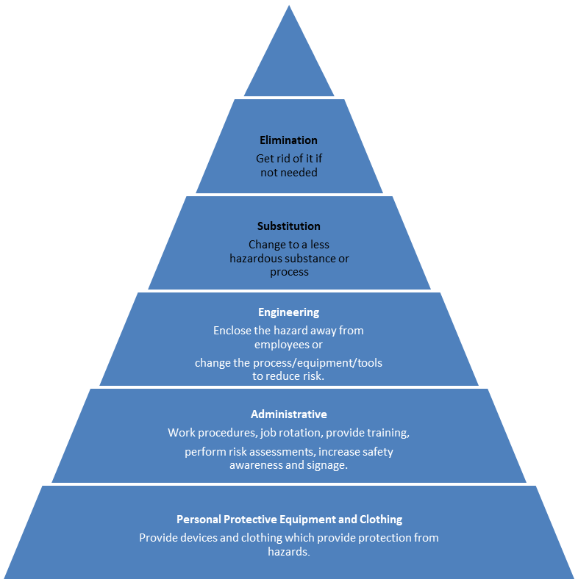

**8. AUTHORISATION** (Office Use Only)

|  |  |
| --- | --- |
| **Austin Health AEC Approval Number:** |  |
| **Internal Reference Number:** |  |
| **Date Approved:** |  |
| **Review Date:** |  |
| **Declaration by Chairperson of the AEC:**  I certify that the procedures have been considered and approved by the Animal Ethics Committee for the period:  _ _/_ _/_ _ _ _ to _ _/_ _/_ _ _ _ | **……………………………………**  Chairperson’s Signature  Print Name:  Date: _ _ / _ _ / 2 0 _ _ |

**9. APPLICATION**

This procedure must be followed by all individuals who are approved by the AEC undertaking this procedure if it is nominated in the specific project.

Any questions, comments or suggestions in regard to this SOP in general, or relating to a specific problem encountered during a procedure should be addressed to the BioResources Facility Manager or the Principal Investigator named on specific projects approved by the AEC.

**END OF DOCUMENT**